**AWS Infrastructure Cost Report for sarvadnya.tech**

**Period:** Oct 1 - Oct 6, 2024   
**Comparison:** Sep 1 - Sep 6, 2024

**1. Executive Summary**

This report provides an analysis of the AWS infrastructure costs associated with deploying the portfolio website, **sarvadnya.tech**, from **Oct 1 - Oct 6, 2024**, with a comparison to the previous period, **Sep 1 - Sep 6, 2024**. The total accrued cost for this period is **$40.02**, compared to **$40.72** in the previous period, reflecting a slight reduction of **1.7%** in overall costs.

**2. Cost Breakdown by Service**

The following breakdown details the individual costs for each AWS service used, alongside comparisons to the previous period and percentage changes:

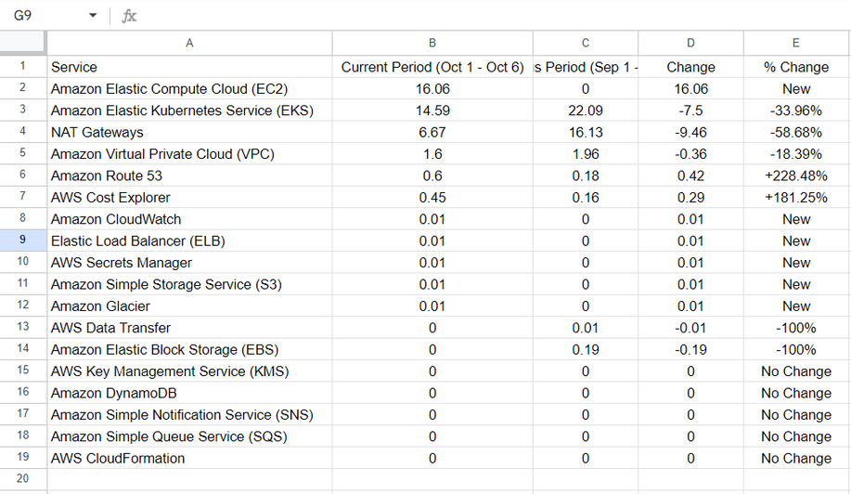

**Total Costs**

* **Oct 1 - Oct 6, 2024:** $40.02
* **Sep 1 - Sep 6, 2024:** $40.72
* **Overall Change:** -$0.70 (-1.7%)

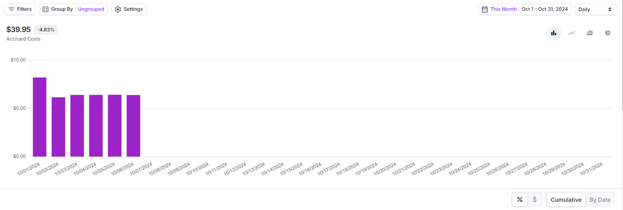

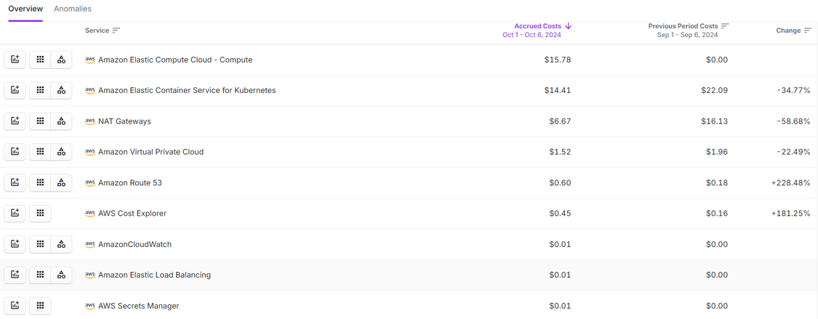

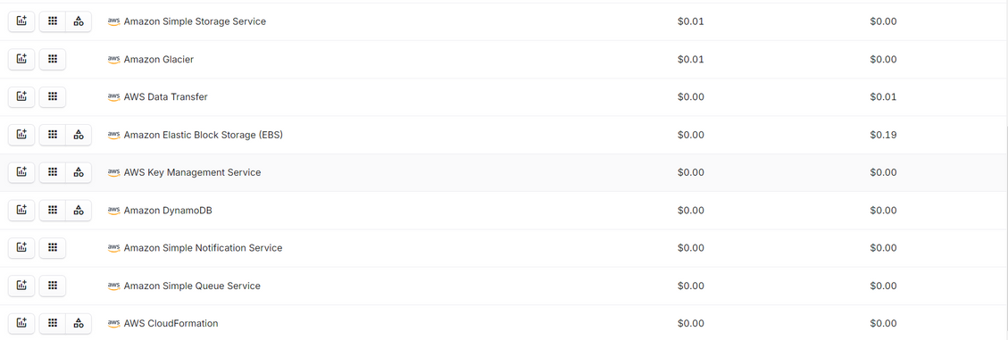

**3. Key Insights**

* **Amazon EC2**: Significant cost increase to $16.06 as it wasn’t used in the previous period, indicating a new deployment or increased server usage during the latest period.
* **Amazon EKS**: A 33.96% reduction in EKS costs reflects more efficient usage of Kubernetes resources, possibly from improved scaling or reduced resource allocation.
* **NAT Gateway**: Costs decreased by 58.68%, signaling an optimization in network traffic or reduced reliance on NAT gateways, which are typically expensive.
* **Amazon Route 53**: A large percentage increase (+228.48%) in DNS management costs may be due to increased traffic or additional DNS configurations for new subdomains or routing policies.
* **AWS Cost Explorer**: Increased by 181.25%, likely reflecting more frequent usage of this tool for cost tracking or optimization efforts.

**5. Conclusion**

The overall costs for the infrastructure powering **sarvadnya.tech** have decreased slightly over the past week, reflecting better utilization of services like **EKS** and **NAT Gateways**. However, there are still opportunities to further optimize costs, especially for **EC2** and **Route 53**. Implementing the above recommendations could yield further savings and improve the cost efficiency of the portfolio site’s infrastructure.